1. Text Error - Hold from Finance Cheak.

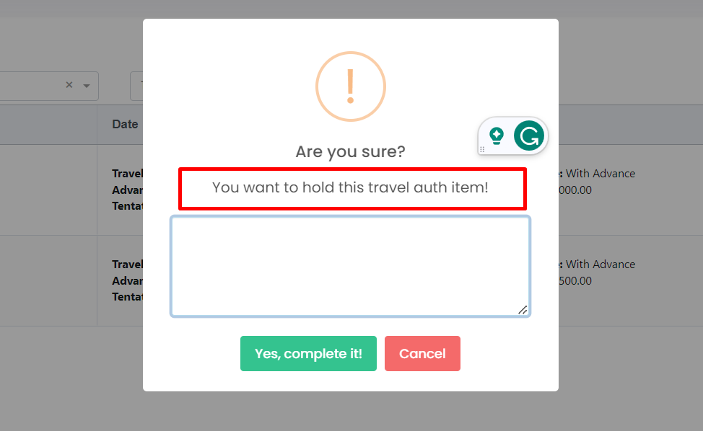

hj

1. **Request No:**TA-04-09-2023-0001 Parking Issues, Shows request on My Approver list

with Advance.

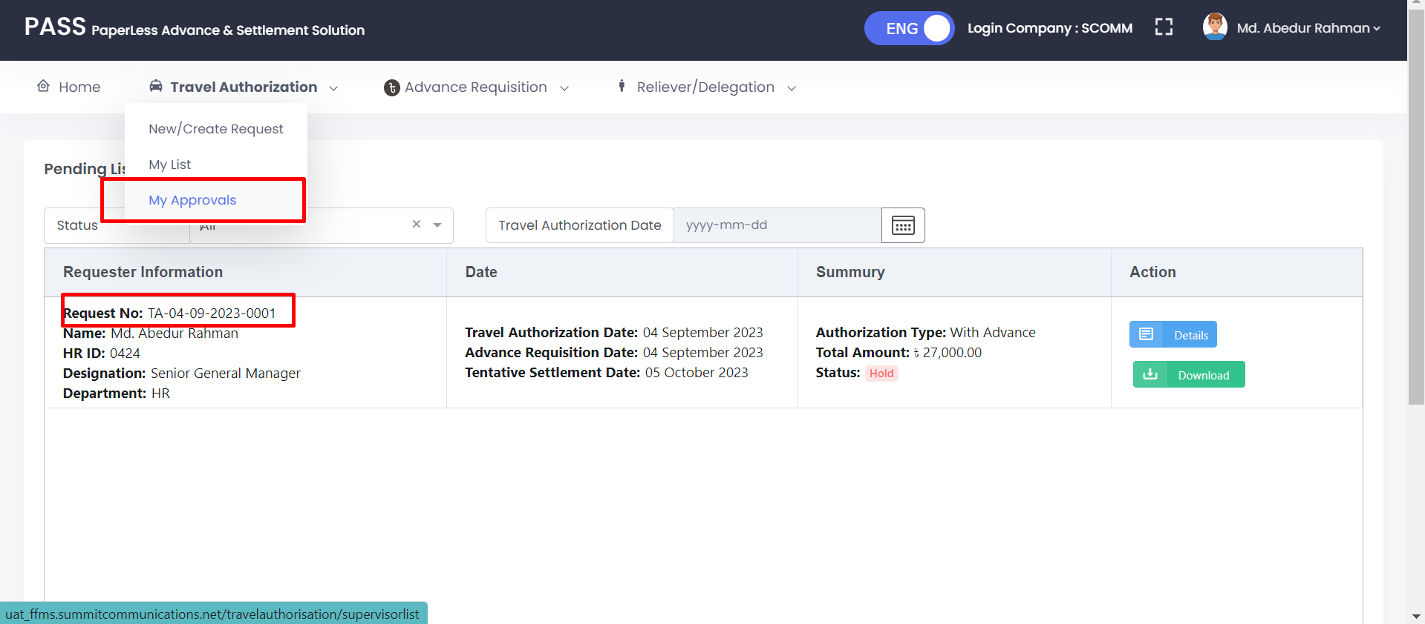



1. **Request No:**TA-04-09-2023-0002 Parking Issues, Shows request on My Approver list without Advance.



